1.
from collections import defaultdict

def group_anagrams(strs):
grouped_anagrams = defaultdict(list)

for word in strs:
key = ''.join(sorted(word))
grouped_anagrams[key].append(word)

return list(grouped_anagrams.values())

# Example 1
strs1 = ["eat", "tea", "tan", "ate", "nat", "bat"]
print(group_anagrams(strs1))

# Example 2
strs2 = [""]
print(group_anagrams(strs2))
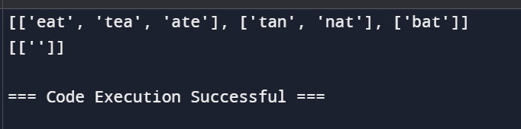
2..

def stringMatching(words):
return [word for word in words if any(other_word.find(word) != -1 for other_word in words if word != other_word)]

# Example
words = ["mass", "as", "hero", "superhero"]
print(stringMatching(words))
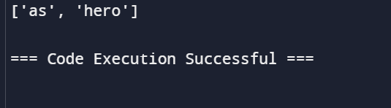

3.
from collections import deque

def updateMatrix(mat):
rows, cols = len(mat), len(mat[0])
queue = deque()

for i in range(rows):
for j in range(cols):
if mat[i][j] == 0:
queue.append((i, j))
else:
mat[i][j] = float('inf')

directions = [(0, 1), (0, -1), (1, 0), (-1, 0)]

while queue:
cell = queue.popleft()
for d in directions:
new_i, new_j = cell[0] + d[0], cell[1] + d[1]
if 0 <= new_i < rows and 0 <= new_j < cols and mat[new_i][new_j] > mat[cell[0]][cell[1]] + 1:
mat[new_i][new_j] = mat[cell[0]][cell[1]] + 1
queue.append((new_i, new_j))

return mat

# Test cases
mat1 = [[0, 0, 0], [0, 1, 0], [0, 0, 0]]
mat2 = [[0, 0, 0], [0, 1, 0], [1, 1, 1]]

print(updateMatrix(mat1))
print(updateMatrix(mat2))

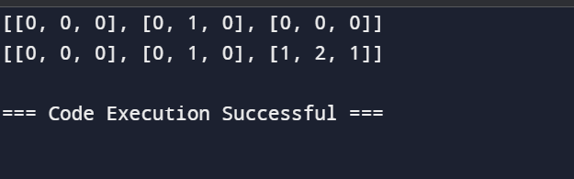

4..
def min_repeats(a, b):
if b in a:
return 1
for i in range(1, len(b)):
if b.startswith(a[i:]):
return 1 + i
return -1

# Example
a = "abcd"
b = "cdabcdab"
output = min_repeats(a, b)
print(output)
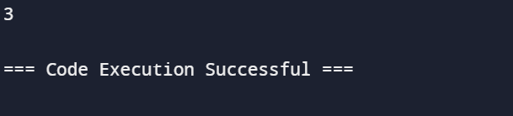

5..
from itertools import combinations

def fourSum(nums, target):
n = len(nums)
result = []
for a, b, c, d in combinations(range(n), 4):
if nums[a] + nums[b] + nums[c] + nums[d] == target:
result.append([nums[a], nums[b], nums[c], nums[d]])
return result

# Example 1
nums1 = [1, 0, -1, 0, -2, 2]
target1 = 0
output1 = fourSum(nums1, target1)
print(output1)

# Example 2
nums2 = [2, 2, 2, 2, 2]
target2 = 8
output2 = fourSum(nums2, target2)
print(output2)
